**April 24-27, 2025, Colorado Railroad Museum-High Plains 3 Railers, Co.**

THE COLORADO RAILROAD MUSEUM PRESENTS THE

**HIGH PLAINS 3 RAILERS MODULAR LAYOUT**

Enjoy the sights & sounds of classic O-Gauge toy trains from 1925 to the present.

Try our ever-popular layout search & find.

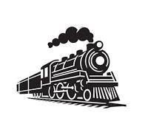

Colorado Railroad Museum

17155 W. 44th Avenue,

Golden, CO

General admission rates apply, which include access to all museum exhibits including the DGRS G-Scale layout and the Denver H.O. Model Railroad.

See you there!!!